
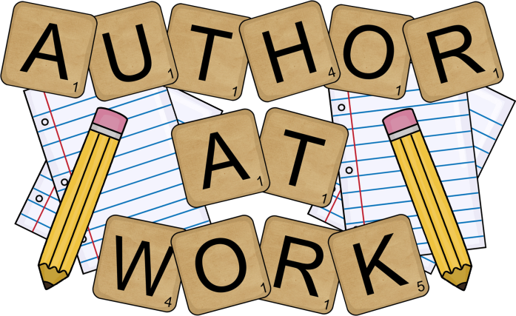

You are invited to an end of the year
WRITERS’ CELEBRATION
on Monday, May 22nd

Here is the schedule for the day:
PreK 9:00-9:30 Cafeteria
Kindergarten: 9:30 - 10:00 Front Grass/Blacktop - Martin/Sentman
In Classroom - Mitchell
First Grade: 10:00-10:30 Back Playground/Grass
Second Grade: 1:30-2:00 Back Playground/Grass
Third Grade: 1:00-1:30 Grass Outside Library
Fourth Grade: 10:30 –11:00 Front Grass/Blacktop
Fifth Grade: 2:00 – 3:00 Gym/Cafeteria

Please join us in celebrating our students
and the end of the year!

*Students will be dismissed at the regular
end-of-day time at 3:15.

