Miss Webb’s Awesome 8th grade reading class SYLLABUS 2015-2016
:) Hello and welcome to reading class! This is going to be a great year, and this sheet contains some helpful notes to help you navigate this class so that you can exceed expectations. The middle school handbook should be consulted for additional information. All information in this syllabus is subject to change if necessary. Please save this sheet! Feel free to contact me at rwebb@huntsd.org.
materials needed:
- pencils
- at least a one-subject notebook (this will be your notebook, not your journal)
- binder or class folder/section in a larger binder for multiple classes
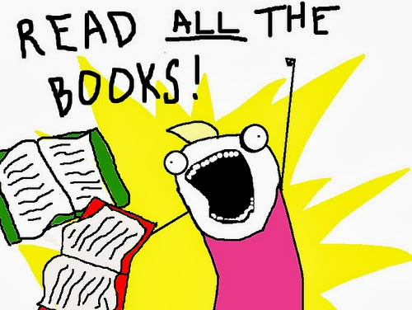
- school-issued agenda/hall pass book
materials provided:
- journal notebook (this will only be for warm-up journal entries)
- 2-pocket paper folders (if desired)
- class novels
novels/reading materials:
    - The Language of Literature textbook (green version)
- Tuesdays with Morrie by Mitch Albom + video [autobiography/memoir]
- The Fault in Our Stars by John Green + video [contemporary fiction]
- Anne Frank (play version) in literature book + video [drama based on Anne’s diary]
- Divergent by Veronica Roth + video [dystopian fiction, sci-fi]
- …other possible options include Anthem by Ayn Rand OR The Boy Who Dared by Susan Campbell Bartoletti
learning objectives and assignments:
For each of the units listed above, there will be a variety of assignments and assessments throughout each marking period. The Pennsylvania Common Core standards for Reading and Language Arts are the building blocks for each lesson. Each of the major units will include questions, quizzes, activities to be completed during reading, a final test, and a final novel project which will allow students to improve their skills in the various aspects of reading comprehension, such as understanding and analyzing plot, setting, characterization, and the use of textual evidence to support a claim. Study guides will be reviewed before each novel test, and rubrics will be provided for all major projects.
My class works on a 100 point scale designed to reflect the rigor of the tasks, and assignments are typically created in 5-point increments. So a small task or question sheet may only be worth 10 or 15 points, a quiz may be 25 or 35 points, and the large final novel tests and projects are worth 100 points each. Assignments and grades can be found on Skyward with due dates and point values, and the office can provide a username and password if necessary. This is the best resource for keeping up with class progress, both for students and parents! I will meet with students individually at least once a marking period to review their progress in my class, but grades should never be a surprise. Please check Skyward!
homework:
Unless specifically noted and addressed, the students will have homework EVERY NIGHT. Throughout the course of the year, students are encouraged to read independently any novels of their choosing, and they will have a reading log to record their progress. They will be expected to read
every night for at least 20 minutes, and then a parent or guardian can initial the reading logs. These will typically be checked once during the middle of the month, and then collected at the end of the month, both for 10 points each, approximately. Due dates and check dates will be listed on each month’s log. These are easy points and they will accumulate to impact the students’ grades.
Other homework is not as frequent, and it will typically be just having the students finish some classwork, such as reading a chapter or responding to literary questions. All homework and all class assignments are listed in TWO places in my room, the weekly objectives board and the homework calendar. Each week, I will create a weekly objectives board to outline our class goals for each day, and this will include notes about homework and upcoming due dates for assignments. Homework is also listed on the designated homework calendar in case, for example, someone is absent on a Friday and they were not able to see the weekly objectives board before it was erased.
extra credit:
Extra credit will be offered in the form of creating an independent novel review poster once per nine weeks. Each student will receive a copy of this rubric at the beginning of the school year. A copy of the rubric will also be available hanging in the room for student review. The projects are optional but encouraged, as they are worth 25 bonus points for each nine weeks. They will be due on the following Wednesdays for each of the marking periods: 10/21, 1/13, 3/16, and 5/25. Other smaller opportunities for extra credit may appear throughout each marking period. Of course, students should first and foremost concern themselves with doing the regular credit so as not to fall behind.
Webbies are another form of extra credit. Essentially, these are dividable raffle tickets. I give one half of the ticket to a student modeling great behavior or showing some impressive intellect. The half they keep can be turned in at any point and on any regular credit assignment, and they are worth 1 bonus point each. I keep the other half with their name on it, and that gets placed into a bucket for a drawing once per nine weeks. The winner will get a gift basket from me which will include fun prizes such as school supplies and snacks.
other information:
I am really excited for my second year in Huntingdon and my fifth full year of teaching overall! My expectations are reasonable, and I am always available to help students, but they must also choose to help themselves. The amount and rigor of work I assign is acceptable for a growing middle school student, and if students put forth an honest effort, they should have absolutely no problem passing this class. My classroom rules ask that students, above all, act respectfully. They are also expected to come to class prepared with all materials and a positive mental attitude, to respond promptly to all directions given, and to place academic issues above social concerns. With each passing day, middle school students should be improving their independent and collaborative work ethics so as to better prepare for the transition to high school. Respect, organization, and effort will mean a ton in this class, as they do in life. Cheers to a wonderful new year!!
***By signing this syllabus, you acknowledge that you have read and understand the material presented here. Signatures will be checked, and this sheet should be SAVED WITH THE STUDENT throughout the course of the school year for reference.***
student name (neatly printed) __________________________________________________
student signature _________________________________________ date ______________
parent/guardian signature __________________________________ date ______________

